**DAY – 3 ASSIGNMENT – 6**

1. **Kanban:**

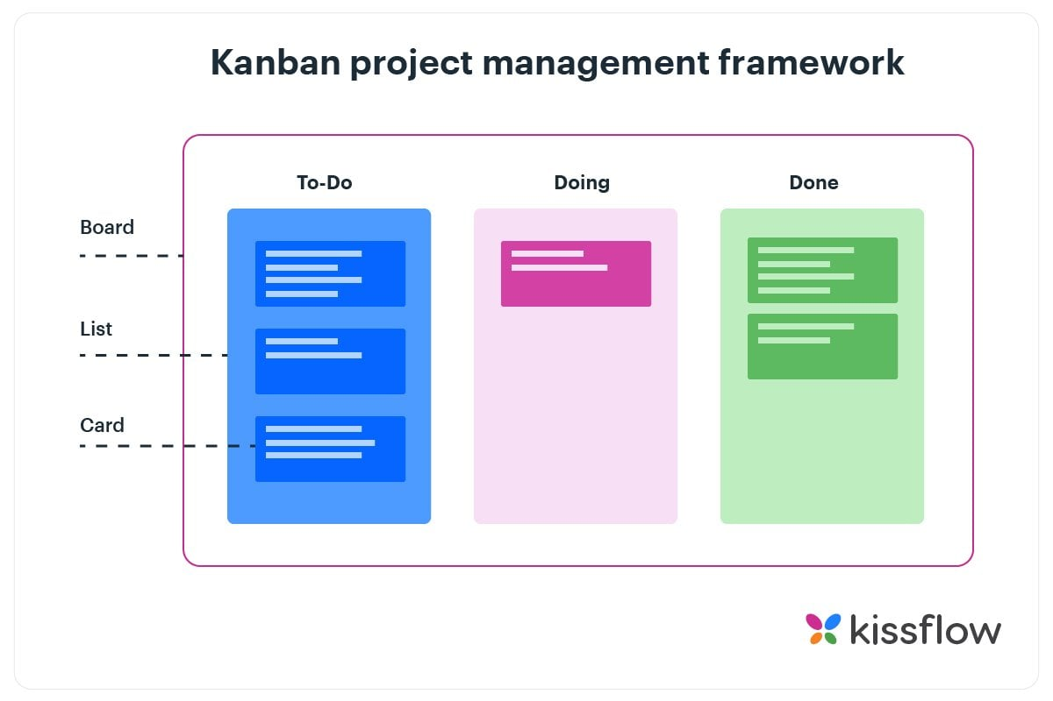

Kanban is a way to organize and manage work by using a board with columns.

* Think of a board divided into parts like:
  + To Do (tasks that need to be done)
  + Doing (tasks you are working on now)
  + Done (tasks you finished)
* Each task is a card that moves from left to right as it gets done.

**Key principles of kanban:**

**Better Visibility:**Everyone on the team can see what work is planned, what is in progress, and what is done — all on one board.

**Faster Delivery:**Work moves smoothly through the process, so completed tasks can be delivered faster to customers.

**Continuous Improvement:**Teams can regularly review the flow of work and improve their process over time.

1. **Lean:**

Lean means **working smarter, not harder**.

It helps us **remove things that waste time or effort** so we can do our work faster and better.

**Key Principles of lean:**

**Remove Waste:**  
Cut out any work or steps that don’t help get the job done.

**Work Faster:**  
Make sure work keeps moving and doesn’t get stuck or delayed.

**Teamwork Matters:**  
Everyone’s ideas and help are important to improve how we work.

**Keep Improving:**  
Always look for small ways to do better every day.